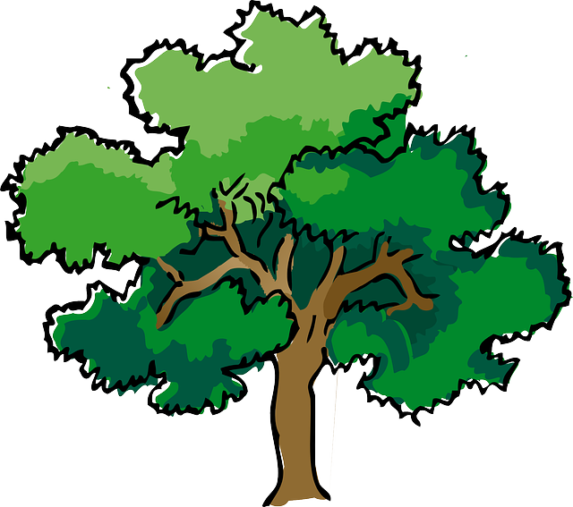
NORTH BAY LEAGUE 9 Team DIVISION
Boys’ Tennis Schedule, 2022 – 2023
(Year 1 of a two-year rotation)
Updated 9/21/22
Preseason meeting: | Monday, January 31, 5:00pm and Montgomery HS Room 80
First day of practice: | Monday, February 6
Number of contests: | 24 matches  A maximum of two (2) scrimmages are permissible prior to the first interscholastic contest (league or non-league) of the season.  Each match counts as one contest in tournaments
Match time: | 3:30pm/4:00 PM
Singles Tournament: Tuesday, April 25 and Wednesday, April 26, site SRHS, Host TBA
Doubles Tournament: Monday, May 1 and Tuesday, May 2, site SRHS, Host TBA

TUESDAY, MARCH 14  Cardinal Newman at Santa Rosa  St. Vincent at Montgomery  Ukiah at Windsor  Analy at Maria Carrillo  Healdsburg Bye | THURSDAY, APRIL 6  Montgomery at Healdsburg  St. Vincent at Ukiah  Maria Carrillo at Windsor  Analy at Cardinal Newman  Santa Rosa Bye
THURSDAY, MARCH 16  St. Vincent at Cardinal Newman  Santa Rosa at Montgomery  Ukiah at Analy  Windsor at Healdsburg  Maria Carrillo Bye | TUESDAY, APRIL 11  Cardinal Newman at Windsor  Healdsburg at Maria Carrillo  Analy at Santa Rosa  Montgomery at Ukiah  St. Vincent Bye
TUESDAY, MARCH 28  Ukiah at Cardinal Newman  Windsor at Santa Rosa  St. Vincent at Healdsburg  Maria Carrillo at Montgomery  Analy Bye | THURSDAY, APRIL 13  Healdsburg at Cardinal Newman  Santa Rosa at Ukiah  Windsor at Analy  Maria Carrillo at St. Vincent  Montgomery Bye
THURSDAY, MARCH 30  Montgomery at Cardinal Newman  Santa Rosa at St. Vincent  Maria carrillo at Ukiah  Healdsburg at Analy  Windsor Bye | TUESDAY, APRIL 18  Santa Rosa at Maria Carrillo  Analy at Montgomery  St. Vincent at Windsor  Ukiah at Healdsburg  Cardinal Newman Bye
TUESDAY, APRIL 4  Healdsburg at Santa Rosa  Cardinal Newman at Maria Carrillo  Analy at St. Vincent  Montgomery at Windsor  Ukiah Bye | Singles Tournament: Tuesday, April 25 and Wednesday, April 26, site SRHS  Doubles Tournament: Monday, May 1 and Tuesday, May 2, site SRHS

NCS AND CIF NOR-CAL CHAMPIONSHIPS
Deadline for leagues to determine qualifiers: May 3, 2022
Final date for Division I – VI competition other than NCS/Les Schwab Tires Championships: May 3
NCS singles/doubles applications due: May 3 by 9 PM
Singles At-large Meeting: May 4, 2022
Singles/Doubles Championships: May 5, 6
NCS team tennis applications due (automatic & at-large): May 3 by 9 PM
At-large Seeding for Team Tennis: May 7
Team Tennis Championships, Division I & II: May 9, 11, 13
CIF Nor-Cal Team Tennis Championships: May 16, 19-20

